Horizon School Web Site Job Aid

Site Content Editing

**Note: Depending on the size of the browser window, the header and menus may look different than expected, this is due to the additional area taken up by the tools menus.

Content Editing
- General Editing Information
  - Build - opens the toolbar with elements needed to add, remove, update content on a page
  - Pages - opens the list of pages on the site and is where pages are added, removed, and page locations are modified
  - Publish - Orange Publish button in the right corner pushes changes out to the live site
- Updating page content
  - Select the Weebly Build menu option
  - Select the page to be updated
    - Adding an element – drag and drop an element from the toolbar to the desired location on the page
    - Moving an element
      - hover over the element until a box appears
      - Click on the box with the dots in it and drag it around the page
    - Removing an element
      - Hover over the element it until a box appears
      - Click on the “X” in the top right corner (confirmation is required)

    - Element Notes – click on an element to set properties
      - Buttons
        - Set text of button
        - Button style – there are several to choose from and can be used to highlight some options
        - Position – left, center, or right justified
        - Link – choose the button function
          - Website URL – link to an external web page
          - Standard page (page on this site)
          - Product Page
          - Blog Post
          - Phone
          - File – link to a document, it will prompt to upload the document
          - Email
          - Spacing – set margins
      - Titles and Text – click on text to launch a menu of option
      - Documents
        - Embedded - Full text will show up on the page
          - Drag the Documents element to the page
          - Click the box to open the options box
          - Click upload file
          - Search for the document or drag and drop
        - Link to document
          - Add text to the page
          - Click on the text to launch the menu bar
          - Select the hyperlink option and chose File
          - Search for the document
          - Choose if it should open in a new window

Adding, Removing, Editing, Moving Site Page

- Current pages are listed on the left side
  - The indentation of the page controls the nesting of the pages
    - Left most pages are menu items at the top of the site
    - Pages 1 indention in are directly under a menu item
    - Pages 2 or more indentions are sub-pages under the one above it
- Adding a page
  - Click on the “+” sign in the black menu bar and select the page type
    - 5 options for page type
      - Standard page – what most of the pages are and indicated by an icon of a piece of paper with a folded corner
      - Blog Page – indicated by a text bubble
      - Store Page – not used
      - External Page – used for links that are used in multiple places on the site so a change to the link only needs to be updated in one place and indicated by an icon of an arrow
      - Nonclickable Menu –what most of the top level menu items are that just direct you to a drop down list of pages and indicated by a dot and three lines

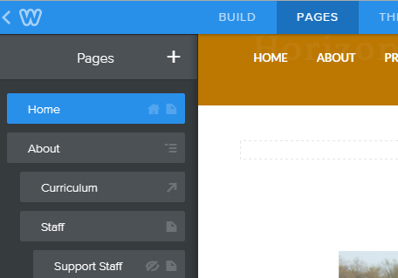

  - Fill in the fields as necessary
    - Page Name
    - Hide in Navigation – select if you want the page to be hidden from public site users
    - Header type – select no Header (it will remove the default picture)
    - External Link – link to page and the option to open in the same tab or a new tab
  - Positon the page
    - The new page will show up at the bottom of the list and is left justified by default so it will also be added to the page menus
    - Click on the page and drag it to the desired position, the page will update dynamically as you move the page
  - Pages can also be copied to save time laying them out
    - Click on an existing page from the list on the left and choose copy
    - The copy will show up the same as a new page at the bottom with the same name
    - Note: this will also copy all of the content to the new page
- Editing Page details (not content)
  - Click on an existing page from the list on the left
  - Update name and visibility option
- Removing a page - Click on a page from the left menu and choose delete

