Horizon School Web Site Job Aid

General and Site Specific Information

General Information
An ID and password is required to modify the site content. Upon login a dashboard of page visit information is displayed. In addition to the dashboard, the following options are available:
- Account Management – Click on the Horizon School link in the top right corner of the page and select Account
  - The Email account and password are managed here
  - Connections to Facebook and Google+ can be added
  - The account can be deleted
- Site Editing – opens the page to edit the site
- Upgrading - To add paid features, click on the Upgrade button
  - Copy or Delete Site - click on the button with the ellipses
- Other items
  - Blog Comments – Comments to the blog will show up here if enabled
  - Form Entries – If forms are used, the responses will show up here
  - Additional tips and links to help manage the site
- Support -
  - Landing page - click on the Horizon School link in the top right corner of the page and select Support
  - Other pages - click on the “?” in the top right corner
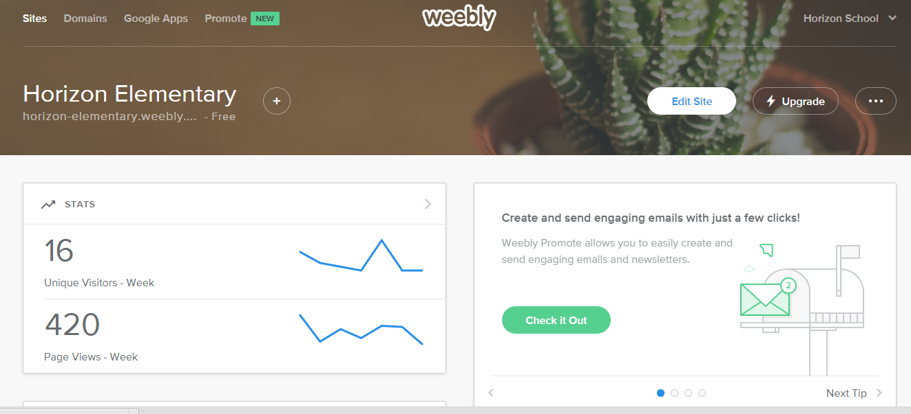

Site Specific Information
- General Information
  - The theme is Saucy and all new pages will be added with this theme by default
  - Navigation
    - The tan and brown menus and buttons are the actual Horizon School site
    - The blue and black menus and tool bars are the Weebly site

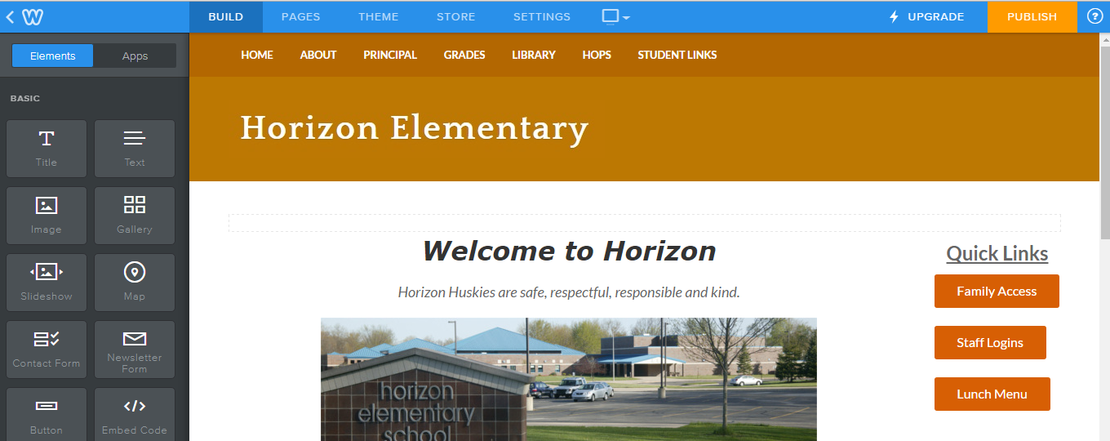

- Setting Menu (relevant Options)
  - General
          - Public Site URL
          - Site title (Header) with the checkbox to show it at the top of all pages
          - Other formatting options for the site like time zone and language
  - Editors
    - Additional people can be set up to edit the site without giving them the main password
  - Blog – options for the blog

